Lab tasks 03

By 21SW159, Section-II

1. Generate a series of Odd number and even number using for and while loop.

**Source Code:**

class Main{

public static void main(String [] args){

byte a= 0;

System.out.println(“Even Odd”);

while(a<=10){

if(a%2==0){

System.out.print(a);

}

if(a%2!=0){

System.out.print(" "+a);

System.out.println();

}

a++;

}//while loop

System.out.println(“Even Odd”);

for(int i=0; i<=10;i++){

if(i%2==0){

System.out.print(i);

If(i%2==1){

System.out.println(“ “+i);

}

}//for loop

}

}

**OUTPUT:**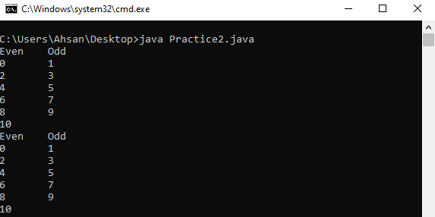

1. Generate all ACSII codes (0-255) using loops in java.

**Source Code:**

class Main{

public static void main(String [] args){

int i = 0;

do{

char c = (char)i;

System.out.print(c+ " ");

i++;

}while(i<=255);

}

}

i = 0;

while(i<=255){

char c = (char)i;

System.out.print(c+ " ");

i++;

}

for(int i=0;i<=255;i++){

char c = (char)i;

System.out.print(c+ " ");

}

}

**Output:**

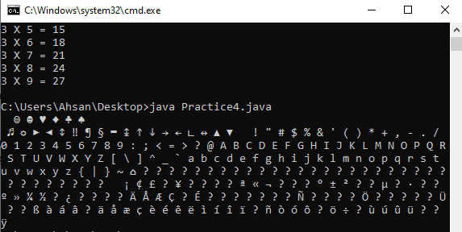

1. Write a java program that takes the table, starting and ending point of the table and prints the output in the following way: (0.3)

Enter Starting point: 3

Enter Ending point: 5

Enter Table No: 5

5x3 = 15

5x4 = 20

5x5 = 25

**Source Code:**

import java.util.Scanner;

class Main2{

public static void main(String [] args){

Scanner s = new Scanner(System.in);

int first,last,table;

System.out.print("Enter first number: ");

first = s.nextInt();

System.out.print("Enter second number: ");

last = s.nextInt();

System.out.print("Enter table number: ");

table = s.nextInt();

for(int i =first;i<=last;i++){

System.out.println(table+" X "+i+" = "+table*i);

}

}

}

**Output:**

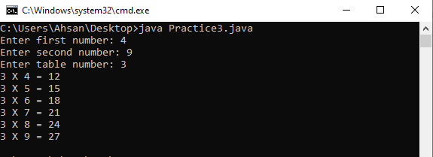

1. Generate diamond structure in java.

**Source Code:**

class Main{

public static void main(String[] args){

byte space = 4;

for(int i = 1;i<=5;i+=2){

for(int j=0;j<space;j++){

System.out.print(" ");

}

--space;

for(int k = 0; k<i;k++){

System.out.print("*");

}

System.out.println();

}

for(int i = 3;i>=1;i-=2){

space+=2;

for(int j=0;j<space;j++){

System.out.print(" ");

}

--space;

for(int k = 0; k<i;k++){

System.out.print("*");

}

System.out.println();

}

}

}

**Output:**

